Word Scramble
  - Overview
- Introduction and Context
This is a brief introduction to the proposed distributed application that your group want to build. It should describe the context of the proposed system, the problem it addresses, and how the proposed system will solve that problem. It should also explain how it meets the project-selection criteria. Finally, identify any resources that your group might to complete the project. This section should be less than one page.
Our distributed application will be a two-player game called Word Scramble. It will largely be based off the board game Scrabble but will have some key differences in game play. Each player will be given an allotted number of letters and will take turns spelling out words on a 16 x 16 tile game board. When a player places a word on the board, that word is checked against a dictionary of valid words. If the word is valid, then the turn is passed to the other player. There is no restriction on where a new word can be played on the game board. Play continues until the game board is filled and no new words can be played. The player with the least number of remaining letters is the winner.
This application will allow us to meet the requirements for this project in the following ways: The application will consist of three distinct shared resources, utilizing a database for the dictionary and to store user information, a file to keep record of games played, and a shared object in the form of a game board. We will have two server programs and a client program that will communicate and allow for seamless game play. There will be several communication protocols in the application using both TCP/IP and UDP protocols. The scope of this application will challenge our skills and abilities but will be attainable within the time frame we have
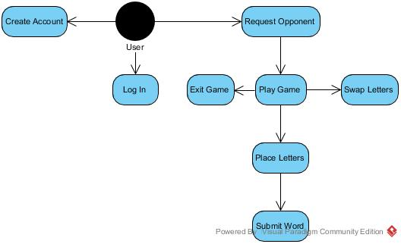
- Actors and their Goals

